Installing Application on an Android Phone

for Infogroup

Setup Document
Version 1.0

This document is an internal document of Valtech which intended solely for the use of Valtech associates. ©Valtech. All rights reserved.

Table of Contents
1 Install Applications on Android without the Market 4
1.1 Enable Unknown Sources 4
1.2 Installing app Using The Conventional Method 5
1.2.1 Step 1: Install File Manager 5
1.2.2 Step 2: Copy .apk file to SD card 5
1.2.3 Step 3: Install .apk 5
1.3 Installing app using Dropbox 6
1.4 Installing app Using the Online Apk Installer 7
1.4.1 Step 1: Upload File 7
1.4.2 Step 2: Scan QR Code 7
1.4.3 Step 3: Install .apk 8
2 Install Application from Google Play / Android Market Place 9
3 Uninstalling application from Android Device 11

Document Control

Change History
Version | Date | Description | Author
1.0 | 5/14/2012 | Installing Application on an Android Phone | Swapneel.J

Distribution List
Name | Position | Organization

Referenced Documents
Reference | Version | Name | Author

Install Applications on Android without the Market
However, there are often times when you may want to install a newly released app or an app that is not available in the Android Market. In these cases you will usually have to manually download and install an .apk file. An .apk file behaves in a similar manner to an “.exe” file on Windows, you need to copy it to your device and run it. Here are some ways that you can manually install an application without going through the market.

Enable Unknown Sources
Before attempting a manual installation of apps using the .apk files, you must first allow your phone to install from “Unknown Sources” (i.e. non-Market apps).
To do this, navigate to Menu -> Settings -> Applications and check the box marked “Unknown Sources“.

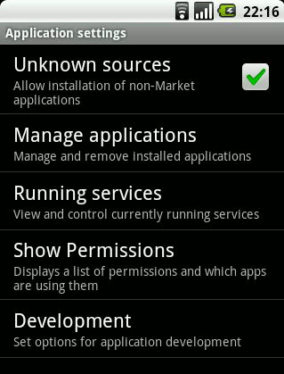

Installing app Using The Conventional Method

Step 1: Install File Manager
Android does not natively come with any method of browsing the data on your SD card, so you will need to install a file manager from a market. There are a large variety of file managers available on Android, commonly recommended is ASTRO File Manager.
https://play.google.com/store/apps/details?id=com.metago.astro

Step 2: Copy .apk file to SD card
Once you have File Manager installed, connect your Android device to your PC using your USB cable. Mount the SD card and copy over the .apk file you would like to install.

Step 3: Install .apk
On your Android device, navigate to the .apk file using File Manager and select it. Please refer screenshot-1
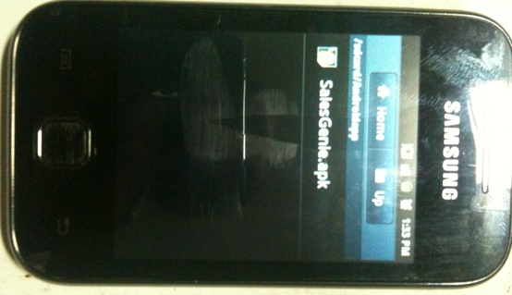
Screenshot-1

Select “Install” to install the .apk. Notification alert will be shown that the app will be using the Android services. Please refer screenshot-2

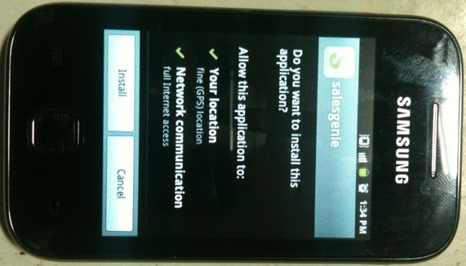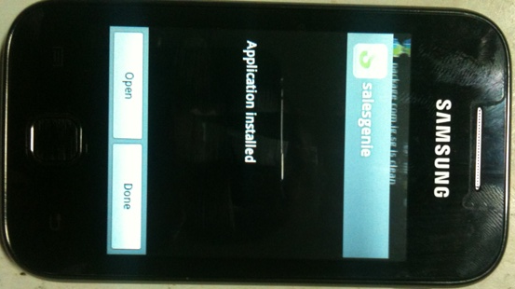

Your new app is now installed.

Installing app using Dropbox

Dropbox is really a versatile app for installing apk file. The method is simple. In your computer, download the apk file to your Dropbox folder. Let it finish syncing. In your phone, open the Dropbox app, navigate to the folder where you keep the apk file, click on it. Dropbox will then download the apk file. The usual installation follows.

Installing app Using the Online Apk Installer

Step 1: Upload File
First, navigate to www.apkinstall.com.
Here you will see a black “Browse Files…” button. Select this and choose the apk file on your PC.
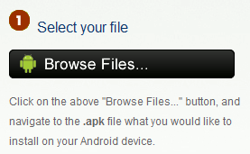
The apk file will remain active on the website for 15 minutes.

Step 2: Scan QR Code
Once you have uploaded the file, a QR code will appear on the website.
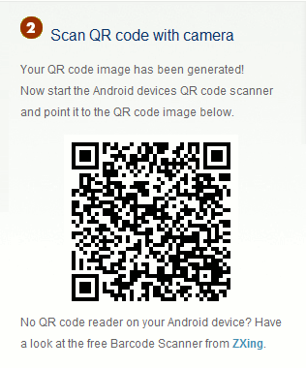

You must scan this QR code with a Barcode Scanner. The website suggests using Barcode Scanner, however I personally prefer using Google Goggles.

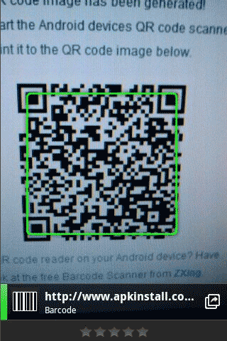

Once the QR code has scanned, you can click on the link to download the .apk file straight to your device.

Step 3: Install .apk
After the .apk file has downloaded to your Android device you can install it by simply clicking on it and navigating through the installation pages.
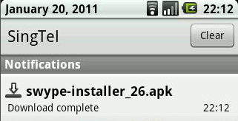

Install Application from Google Play / Android Market Place
Step 1: To access Android Market Place; launch Google Play from your Android Device
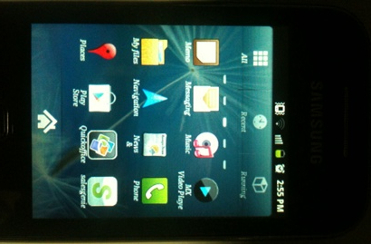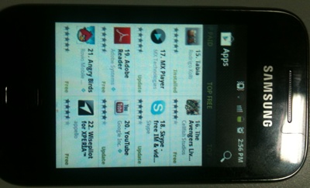

Step 2 : Search application that you would like to install. In this example we’ll try to install Adobe reader
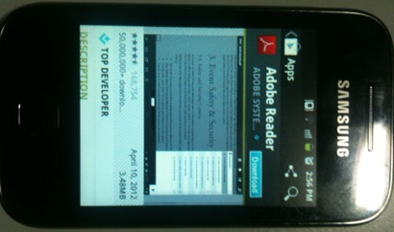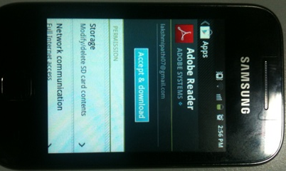

Step 3 : On Clicking Accept and Download. Automatically app will be downloaded and installed onto your device.
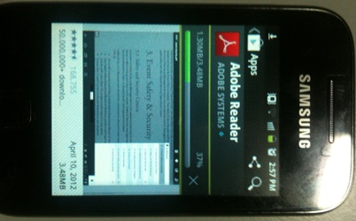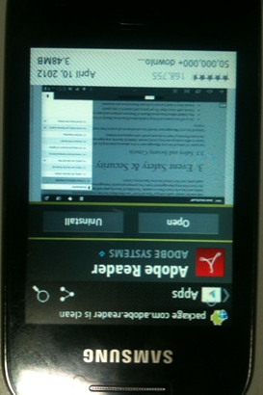

Your new app is now installed.

Uninstalling application from Android Device
Step 1 : Navigated to Settings Menu
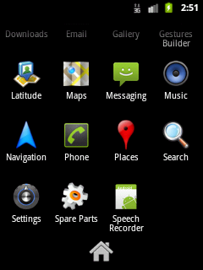

Step 2 : Click Application Options from the list
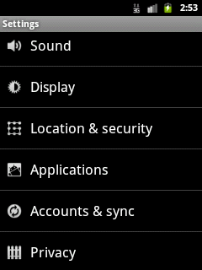

Step 3 : Click Manage Applications
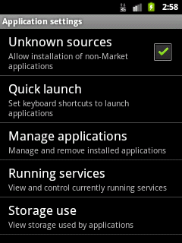

Step 4 : Select Application that you want to uninstall
